WHY WAIT REPORT FOR TERM ONE 2015/2016 ACADEMIC YEAR (SEPTEMBER TO DECEMBER 2015).

SUMMARY
On behalf of FLAEM, I wish to express my appreciation for the funding given by the donor for the past couple of years. It is a blessing that despite the hard financial times that the world over is going through, our donor continues to fund the activities. Sacrifice is the only word that can explain this gesture. We pray that the Lord will be glorified through the work.
We hope and pray that the Lord will raise more well-wishers to be supporting this work. As mentioned in the report, there are many schools that are waiting for the Why Wait programme to reach out to them. While we have the capacity and ability to reach out to such schools, finances are the stumbling block. Please join us!
We thank God for His guidance. We are also grateful to the teachers who are very committed and the learners for their love for Why Wait.
The report covers the first term of 2015/2016 academic year which run from September 2015 to December 2015. The project activities took place in forty-four schools in Mulanje district covering four zones namely, Ulongwe, Chambe, Namphungo and Maveya.
TRAINING FOR TEACHERS
Refresher courses took place at each of the four Teacher Development Centres. Attendance was excellent in all centres. This is an indication that the teachers value the project highly. The Primary Education Advisors (who are responsible for the zones) officially opened the courses and participated in the training. This is another positive development because it enables them to include Why Wait activities in their supervision visits to the schools.
At Ulongwe Zone, we had a rare opportunity of having the newly appointed Schools Supervisor, Mr. Witness Mission in attendance. The Ministry of Education has re-introduced the positions of Schools Inspectors. Mr. Mission is currently head teacher for Mulanje CCAP Mission School. Speaking at the end of the training Mr. Mission challenged the teachers to ensure that Why Wait appears on the schedule of subjects because every time he visits the schools he will check on what is happening on Why Wait. FLAEM is grateful for this commitment.
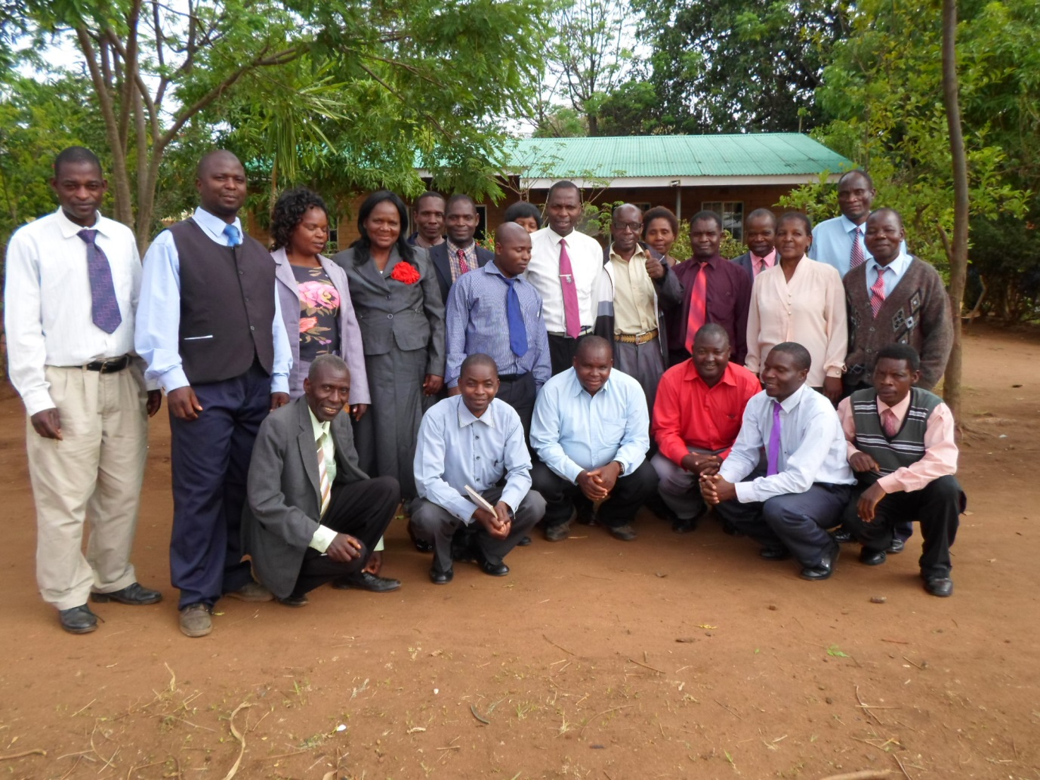Mr. Witness Mission, Inspector of Schools (standing far right) poses with head teachers of Ulongwe Zone
Three hundred and sixty-four teachers and head teachers from the participating schools were trained during the three day refresher course. The refresher course gave the teachers an opportunity to discuss the success stories of their different schools as well as the challenges faced in the implementation of the activities. This was a great learning opportunity not just for the teachers but even for FLAEM. It was interesting to see that some of the issues that had been presented as problems in the previous training sessions had been successfully dealt with in the different schools. This is proof that the training sessions are helpful.
The number of new teachers trained this time around was quite significant. This brings about the need for more manuals. The manuals are the curriculums that contain the course content for each class. For effective teaching each teacher needs to have the class curriculum and a Teacher’s Handbook. We need to make additional copies of the materials. We need $5 (5dollars) for each book. A total amount of $5,000 (5 thousand dollars) will give us sufficient books for the year. The availability of sufficient books will also help the teachers to prepare their learners well for the quiz competition to be held in June.
It was also evident that many teachers have a better understanding of the Why Wait concept. Proof of this was that almost every teacher wanted to share how his/her school was doing. Many teachers explained how the learners are able to correct one another especially in the use of vulgar/abusive language. Some learners come from homes where the use of vulgar language is not an issue.
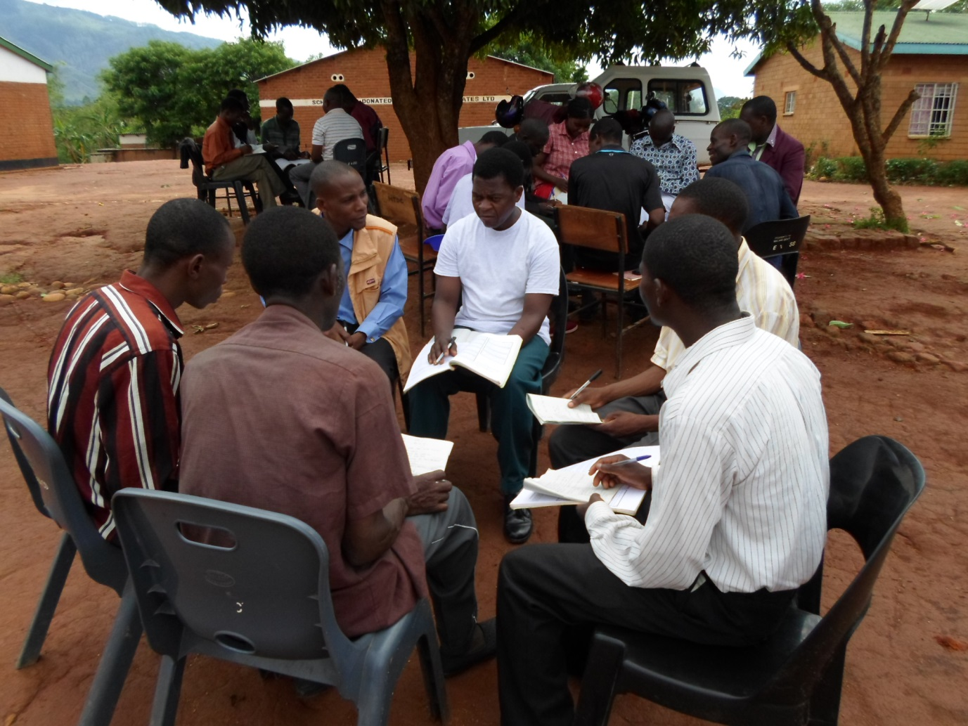
Group work during a training session
QUIZ COMPETITION
The issue of quiz competition was also discussed at length. Every participant agreed that the competition be conducted this academic year. It was agreed that the Primary Education Advisors will be responsible for the organisation and running of the competition in their respective zones. They will, together with the head teachers, form the necessary committees to oversee the running of the competition. FLAEM will come in at the district level where each zone will have produced a zonal winner (school). FLAEM will manage the finals to identify the district winner.
FLAEM is very happy with this arrangement because it makes the schools responsible right from the word go. This also assures sustainability of the competition. The fact that the schools have made this decision is an indication that they value the competition and the programme as a whole.
THE WEBSITE
The website, (www.flaem.org), was another wow! moment during the training. The teachers that had previously visited the site were impressed. Those that had photos from their schools proudly shared with their colleagues. This was another engorgement to FLAEM that teachers visit the site despite it being expensive (internet access is very expensive in Malawi).
FLAEM would like to thank Mr. Frans Visscher and team for the good work being done on the website. Positive comments on the website have also been received from other quarters.
MONITORING FORMS
The teachers agreed that the monitoring forms be maintained in the present format. The form is easy to complete and captures the relevant information. There is a form for each stream (i.e. a school that has say three streams for a particular class has separate forms for each stream). This ensures that each stream is assessed separately. The deputy head teachers have been very helpful in the data collection and compiling of the same. This has proved that the idea to include them in the training was a right one
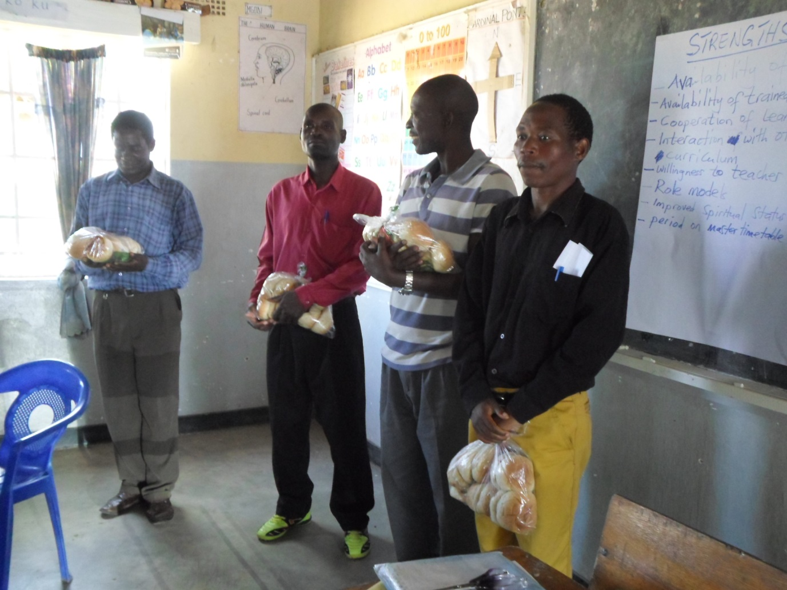
These head teachers were recognized as star performers in the completion and submission of monitoring forms from Namphungo zone. They are recognized and rewarded at a training session
WHY WAIT CLUBS
Many schools reported to have established the clubs as an extra-curriculum activity. Some schools have the clubs meeting every week during extra-curriculum activities. The majority of the schools continue to meet once a fort night. The original idea was that the learners would be meeting once every week during clubs and societies time. However, the Why Wait clubs attract many learners and this had an effect on the other clubs. Many schools therefore decided that Why Wait club activities be held separately from the other club days.
In addition to the usual meetings at the school where the learners share skills and knowledge e.g. hand craft where they make brooms and other things, the clubs have continued to assist the general public in different ways. Some schools have assisted the elderly by cleaning the surroundings of their homes. Other schools have gone to work at public amenities e.g. health centres.
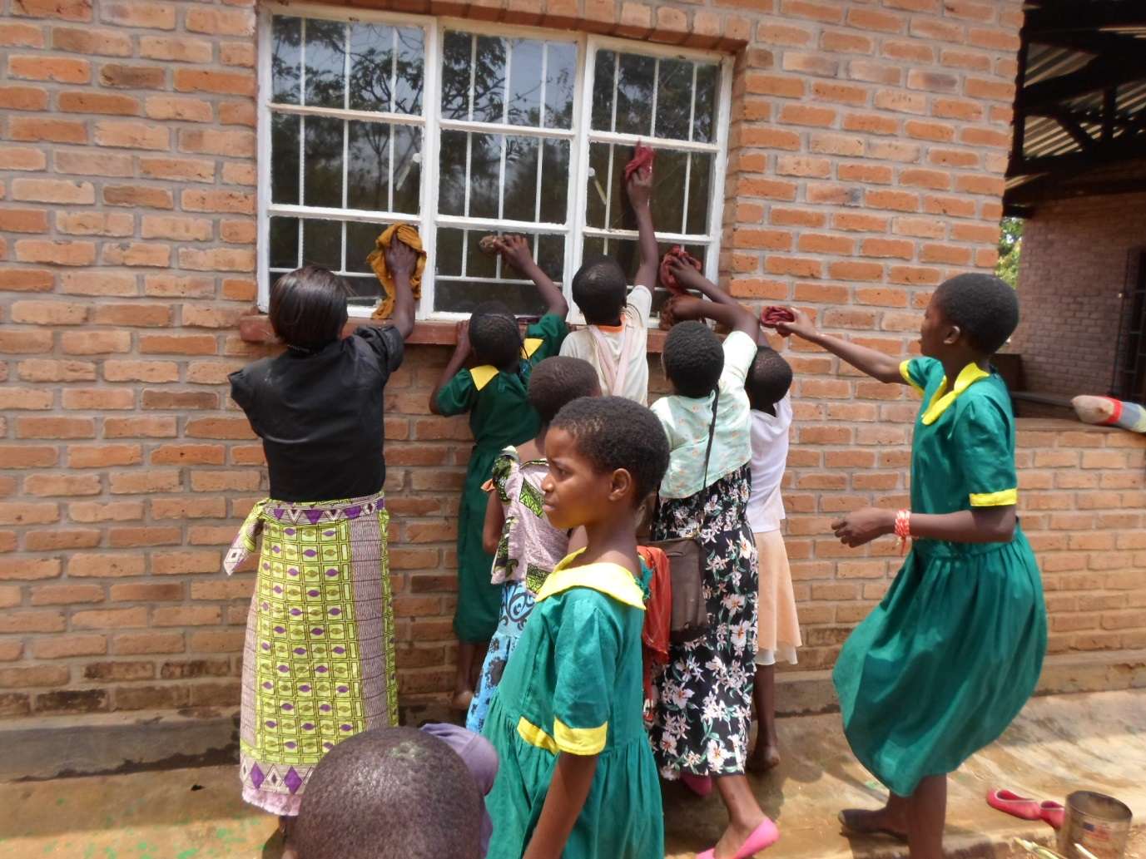
A teacher (in black blouse) assists learners in a cleaning exercise at Ngolowera Health Post

IMPACT
Why Wait continues to have a very positive impact in the participating schools. Both learners and teachers speak highly about Why Wait. Head teachers have said in confidence how some teachers have transformed following their involvement in the programme.
At one of the schools one teacher confessed that if it were not for Why Wait he would have continued his behaviour of alcohol abuse. He said that when he came to this particular school which is participant in Why Wait, he was challenged by the content. He eventually decided to stop drinking. He further said that he now has a better family life and the management of his finances has changed for the better.
FLAEM has no doubt that the progrmme is not just benefitting the learners and teachers. The transformation that is taking place in the learners and teachers obviously has an impact in the community. Other schools that are not participating in the programme continue pestering FLAEM to extend the programme to their schools. It is for this reason that FLAEM appeals to well-wishers to give the financial support for the extension of the programme to those schools (see our website on how you can adopt a school).
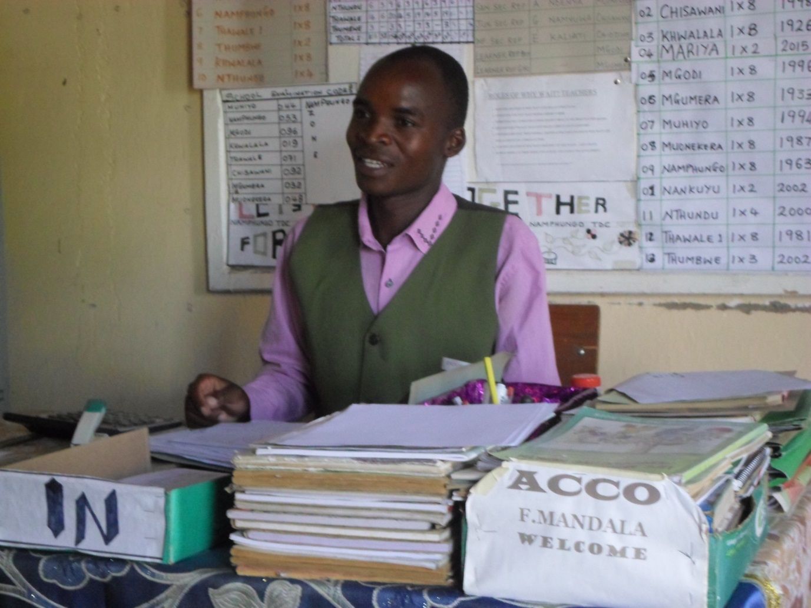
Mr. Fanuel Mandala is the acting Primary Education Advisor for Namphungo Zone. He says Why Wait has helped to bring discipline among learners and teachers in the zone

SUPPORT FROM THE DISTRICT EDUCATION OFFICE

The District Education Office in Mulanje continues to support the project. FLAEM is free to go to the schools without any restrictions. The District Education Manager, Mr. Gossam Mafuta keeps saying that the Why Wait program is a must for all schools. He is among those people who wishes the programme extended to all schools in the district.
FLAEM is very thankful for the support. We sincerely hope that all who will read this report will see the need for supporting FLAEM to extend to the schools that are unreached by now. There are nine zones with more than eight schools that FLAEM is not reaching out to. Please support FLAEM now.

STATISTICS OF THE WORK DONE
Zone | Schools |  | Number of learners accessing Why Wait lessons per class
 |  |  | Class 5 |  |  | Class 6 |  |  | Class 7 |  |  | Class 8
 |  |  | Boys | Girls | Total | Boys | Girls | Total | Boys | Girls | Total | Boys | Girls | Total
Maveya | Ruo |  | 43 | 35 | 78 | 26 | 49 | 75 | 26 | 47 | 73 | 26 | 16 | 42
 | Nalingula |  | 80 | 78 | 158 | 27 | 35 | 62 | 30 | 30 | 60 | 29 | 27 | 56
 | Zimbo |  | 99 | 88 | 187 | 61 | 74 | 135 | 78 | 67 | 145 | 74 | 63 | 87
 | Namame |  | 43 | 42 | 85 | 63 | 71 | 134 | 71 | 76 | 147 | 48 | 48 | 96
 | Chiringwe |  | 49 | 43 | 92 | 48 | 53 | 101 | 40 | 30 | 70
 | Maveya |  | 85 | 79 | 164 | 48 | 49 | 97 | 46 | 41 | 87 | 42 | 39 | 81
 | Chisambo |  | 47 | 55 | 102 | 28 | 22 | 50 | 24 | 12 | 36 | 37 | 18 | 55
 | Songwe |  | 63 | 74 | 137 | 69 | 51 | 120 | 41 | 24 | 65 | 22 | 11 | 33
 | Ngangala |  | 149 | 135 | 284 | 134 | 147 | 281 | 87 | 86 | 173 | 71 | 54 | 125
 | Mabanja |  | 92 | 95 | 187 | 37 | 39 | 76 | 53 | 37 | 90 | 27 | 30 | 57
 | Lujeri |  | 113 | 98 | 211 | 48 | 54 | 102 | 72 | 63 | 135 | 78 | 68 | 146
GRAND TOTAL |  |  | 863 | 822 | 1,685 | 589 | 644 | 1,233 | 568 | 513 | 1,081 | 454 | 308 | 762
Chambe | Pasani |  | 111 | 112 | 223 | 51 | 56 | 107 | 48 | 68 | 116 | 34 | 67 | 101
 | Nolo |  | 44 | 43 | 87 | Junior School (up to standard 5 only)
 | Kambenje |  | 154 | 169 | 323 | 115 | 123 | 286 | 72 | 82 | 154 | 60 | 45 | 105
 | Nansato |  | 115 | 137 | 252 | 51 | 74 | 125 | 49 | 79 | 128 | 53 | 50 | 103
 | Samson |  | 110 | 149 | 259 | 117 | 96 | 213 | 114 | 96 | 210 | 95 | 76 | 161
 | Sukayakwe |  | 82 | 78 | 160 | Junior School (up to standard 5 only)
 | Nogwe |  | 92 | 94 | 186 | 105 | 128 | 233 | 54 | 50 | 104 | 37 | 22 | 59
 | Nkanda |  | 351 | 437 | 788 | 218 | 216 | 434 | 137 | 147 | 284 | 111 | 70 | 181
 | Mthuruwe |  | 142 | 196 | 338 | 148 | 120 | 268 | 118 | 102 | 220 | 38 | 21 | 59
 | Likuwa |  | 60 | 59 | 119 | 64 | 64 | 128 | 42 | 26 | 68 | 53 | 39 | 92
 | Namindola |  | 111 | 100 | 211 | 115 | 120 | 235 | 86 | 134 | 220 | 44 | 33 | 77
 | Likuwa |  | 42 | 39 | 81 | 47 | 42 | 89 | 52 | 43 | 95 | 39 | 23 | 62
 | Namadidi |  | 49 | 120 | 169 | 86 | 87 | 173 | 42 | 52 | 94 | 56 | 39 | 95
 | Nsuka |  | 38 | 58 | 96 | Junior school (new)
 | TOTAL |  | 1,501 | 1791 | 3292 | 1117 | 1126 | 2,243 | 814 | 879 | 1,693 | 620 | 485 | 1105
Nam-phungo | Muhiyo |  | 97 | 120 | 217 | 111 | 126 | 237 | 85 | 110 | 195 | 39 | 11 | 50
 | Khwalala |  | 102 | 109 | 211 | 60 | 72 | 132 | 52 | 54 | 106 | 30 | 17 | 47
 | Mgodi |  | 39 | 38 | 77 | 23 | 24 | 47 | 17 | 21 | 38 | 13 | 7 | 20
 | Thawale |  | 125 | 150 | 275 | 74 | 79 | 153 | 54 | 64 | 118 | 32 | 15 | 47
 | Muonekela |  | 89 | 99 | 188 | 50 | 48 | 98 | 52 | 47 | 99 | 26 | 11 | 37
 | Chisawani |  | 65 | 73 | 138 | 49 | 44 | 93 | 32 | 40 | 72 | 25 | 24 | 49
 | Mgumela |  | 88 | 114 | 202 | 56 | 77 | 133 | 57 | 57 | 114 | 26 | 24 | 50
 | Namphungo |  | 57 | 52 | 109 | 55 | 53 | 108 | 58 | 38 | 96 | 39 | 32 | 71
 | TOTAL |  | 662 | 755 | 1,417 | 535 | 478 | 1,013 | 407 | 431 | 838 | 230 | 141 | 371
Ulongwe | Chibanthe | 37 |  | 36 | 73 | 36 | 49 | 85 | 38 | 47 | 85 | 18 | 14 | 32
 | Kang’oma | 49 |  | 64 | 113 | 43 | 37 | 80 | 34 | 20 | 54 | 20 | 21 | 41
 | Kanjedza | 39 |  | 29 | 68 | 39 | 31 | 70 | 33 | 20 | 53 | 29 | 10 | 39
 | Likhubula | 70 |  | 69 | 139 | 53 | 62 | 115 | 45 | 45 | 90 | 67 | 52 | 119
 | Mapereka | 45 |  | 52 | 97 | 62 | 64 | 126 | 29 | 16 | 45 | Junior School
 | Mikoko | 50 |  | 74 | 124 | 46 | 49 | 105 | 58 | 47 | 105 | 19 | 12 | 31
 | Misanjo | 76 |  | 76 | 152 | 68 | 68 | 136 | 70 | 70 | 140 | 49 | 45 | 94
 | Mulanje Mission | 245 |  | 247 | 492 | 248 | 250 | 498 | 180 | 197 | 377 | 87 | 116 | 203
 | Nalipiri | 80 |  | 91 | 171 | 49 | 42 | 91 | 35 | 31 | 66 | 24 | 36 | 60
 | Ngolowela | 61 |  | 50 | 111 | Junior Primary School
 | Ulongwe | 39 |  | 39 | 78 | 56 | 55 | 111 | 40 | 42 | 82 | 22 | 18 | 40
 | TOTAL | 791 |  | 827 | 1,618 | 700 | 707 | 1,407 | 520 | 535 | 1,055 | 335 | 324 | 659
Summary of participants per class:
Class | 5 |  |  | 6 |  |  | 7 |  |  | 8
 | Boys | Girls | Total | Boys | Girls | Total | Boys | Girls | Total | Boys | Girls | Total
 | 3,817 | 4,195 | 8,012 | 2,941 | 2,555 | 5,496 | 2,309 | 2,358 | 4,667 | 1,639 | 1,258 | 2,897

Total number of learners participating in the programme in term one:
Boys | 10,706
Girls | 10,366
Grand total | 21,072

There has been a big increase in the numbers (21,072) compared to end of year last year (17,856). While the increase of 3,216 is a result of a number of factors such as a few schools graduating from Junior to Senior Primary Schools category thereby having more classes, it cannot be denied that the introduction of Why Wait in these schools is also contributing to the retention of learners in the schools. The numbers may decrease a bit in the other terms because some learners drop out due to poverty which makes it difficult for some learners to afford some basic necessities such as exercise books, pens and soap for washing clothes. FLAEM would therefore welcome gifts such as exercise books, pens etc. to assist the learners that are in dire need.
LESSON/TOPICS COVERED
The table below shows the minimum expected number and topics of lessons to be covered in the first term.
Lessons for standard 5:
Lesson No. | Topic | Theme
 | Nobody’s a nobody | Each person is special in God’s eyes, and has worth
 | The Drought | God always provides a warning for His people for bad times to come. If the people listen, they will survive through the difficulties.
 | Rules and responsibilities | God gives people the gift of free will that allows them to make choices. People show love for God and a sense of responsibility to their communities when they choose to follow good rules.
 | Many hands make light work | God create people to love and help one another in many different ways.
 | Working together | God created families to love and help one another and other families in their communities
 | Encouragement to persevere | Jesus gave us the great commandment: Love God and love others as we love ourselves
 | Justice | God has given us the Bible to set a standard for justice

Lessons for standard 6:
Lesson No. | Topic | Theme
1 | Families are special | The family is God’s plan of creation. Each member of a family, of whichever generation, is special, making the family as a whole special in God’s eyes.
2. | Family hospitality | A family shows hospitality when it opens its home and its heart to others in need or to celebrate with friends
3. | Family rights and responsibilities | The largest family each one of us belongs to is the human family
4. | Working with feelings | How we deal with one another’s feelings reflects our understanding, or lack of understanding, of God’s love for us
5. | Is family a bone? | God specifically commands us to honour our parents and elders, but at the same time He expects the relatives to respect their children, and in particular to take care of orphans.
6. | Superstitions | God told us to love Him with all our heart, mind, soul and strength. If we do this, we have no need to believe in the possibility of good or bad things happening purely by chance or because of a particular event such as an owl hooting.
7. | Preparations for traveling | God advises His people to plan well, unless we know where we are going or what we are doing, why we are going there or doing that, and what we need for the journey or activity, we run the risk of forgetting key aspects, and so being unable to accomplish our goals

Lessons for standard 7:
Lesson No. | Topic | Theme
1 | Developing friendships | Friendship evolves when two people make time for one another to share activities, plans and interests.
2. | Teasing and revenging | God never laughs at us, uses us, or takes revenge on us.
3. | Be a friend to have a friend | A good rule to guide your behaviour is to ask yourself “Would I want him or her to treat me like this?”
4. | Each one of us is special | Each one of us comes to know who he or she is through experience, observation and reflection.
5. | Parents and friends C-A-R-E | Jesus has shown us how to love and care for those who suffer from disabilities, and for those whose lives have been hurt by wrong choices they or others have made.
6. | Families and health habits | God has placed people in families to provide the family members with opportunities to learn good health habits and to protect them from making choices that could be bad for their health.
7. | Who am I | “You are what you have been becoming”

Lessons for standard 8:
Lesson no. | Topic | Theme
1. | The child from nowhere | God’s character includes compassion for all the people of the world.
2. | A very special promise | Each person is valuable and special, because God created them and loves them all.
3. | God is nowhere? God is now here? | The character of people who believe that God is with them is much more stable than that of people who believe God is distant and unreachable.
4. | Responsibility | One of the values and characteristics that a society needs in its individuals is sense of responsibility to themselves and others
5. | Patience | One of the values and characteristics that a society needs in its individuals is patience with themselves and with others, so that peace prevails.
6. | Learning to wait | Young people need rationale to wait, in light of negative peer pressure, but they also need the strength to stick to the decisions to wait.
7. | Why wait? | God demonstrates respect for people by talking and listening to them. But people often fail to show respect to others by talking and listening equally careful to those who look different from them.

It is encouraging to note that a number of schools have actually beaten this minimum number of lessons. The Quiz competition that will be conducted towards the end of the year is a big inspiration to the teachers to teach more. In total there are 36 lessons for each class.
SOME COMMENTS FROM TEACHERS
- Sexual relationships among learners reduced because of Why Wait
- FLAEM should increase the training days for teachers to at least three for the teachers to be well grounded in the material
- Teachers have additional skills and knowledge from the Why Wait material
- Learners are able to relate what they learn to their real life situations
- Why Wait is critical especially now when Video show rooms are rampant in many communities (these shows are not censored and usually show inappropriate material)
- Performance of girls has improved at Kambenje school following sensitization by FLAEM staff. Many girls were selected to secondary schools
VOTE OF THANKS
FLAEM is very grateful to the donor who made it possible for this great work to be accomplished. Without the funds, all this would have been a mere wish. It is clear from the reports on the ground that both the youths and the teachers have benefitted a lot. A lot of lives have been impacted. FLAEM shall ever remain thankful.
We also wish to thank Mr. Frans Visscher for his untiring efforts in supporting the work of FLAEM in different ways. FLAEM staff has benefitted a lot from his expertise. There are many other people who support the Why Wait activities silently through prayer and other ways. Their great work is appreciated and will never be taken for granted. Those who wish to support FLAEM may contact us as advised on the website.
CONCLUSION
It is evident that the Why Wait programme is very important and essential. We are proud to see the results on the ground. We are very thankful to all that have joined hands with us. It is our sincere hope that many more will join hands with us. We have the ability to do more if you support us. Everyone wishes to be associated with success. FLAEM is hereby giving you the opportunity to do so.
We are grateful to God for giving us the wisdom and strength to be doing this work. Without Him we can do nothing.

